**For Instant download solution click on this link**

[**https://devrysolutions.com/downloads/new-soln-cis407a-assignments-week-2-lab/**](https://devrysolutions.com/downloads/new-soln-cis407a-assignments-week-2-lab/)

**Get Help for Entire Coursework for this course. We shall do every task including discussions. Contact:**

**Whatsapp +1(765)-470-9090**

**New Soln] CIS407A Assignments Week 2: Lab**

* 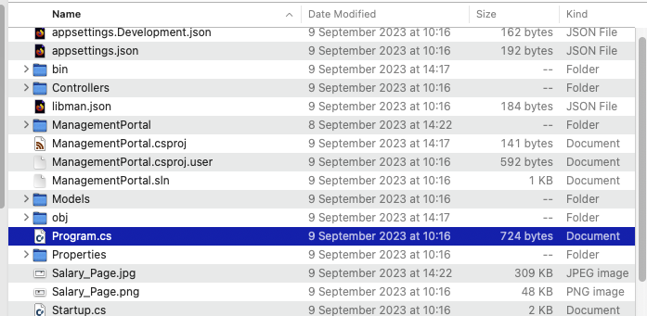

**Week 2: Lab**

* Due Saturday by 11:59pm
* Points 50
* Submitting a file upload
* Available Sep 3 at 12am – Oct 14 at 11:59pm

**Lab 2: User Input Pages**

**Lab Overview**

**Scenario/Summary**

In this lab, we will demonstrate how to create an ASP.NET Web application using MVC. In this application we will create a new model and learn how to make our web application responsive.